EXPERIMENT-1
ROLL NO:240701595 NAME:vishaali R

USER INTERFACE AND DESIGN
COMAPARSION OF UI DESIGN BETWEEN TWO FIGMA CREATION
BAD WEBSITE:
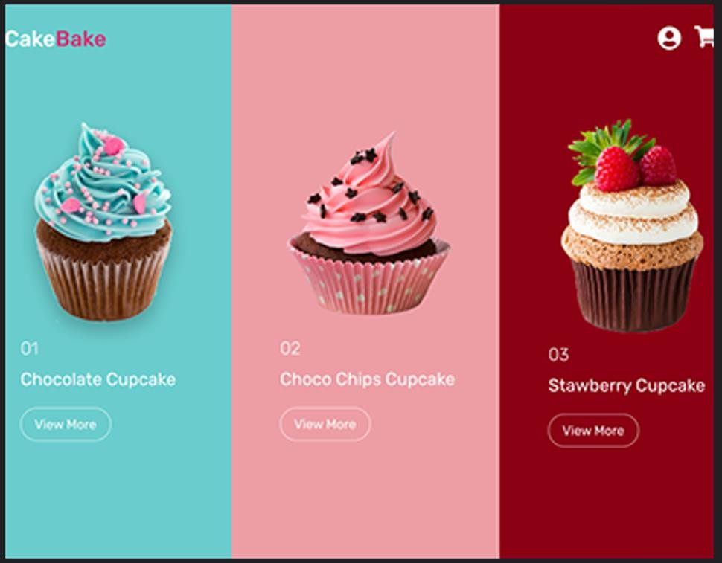
GOOD WEBSITE:

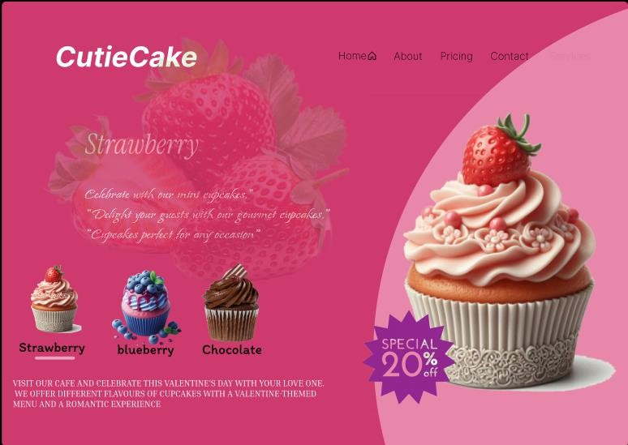
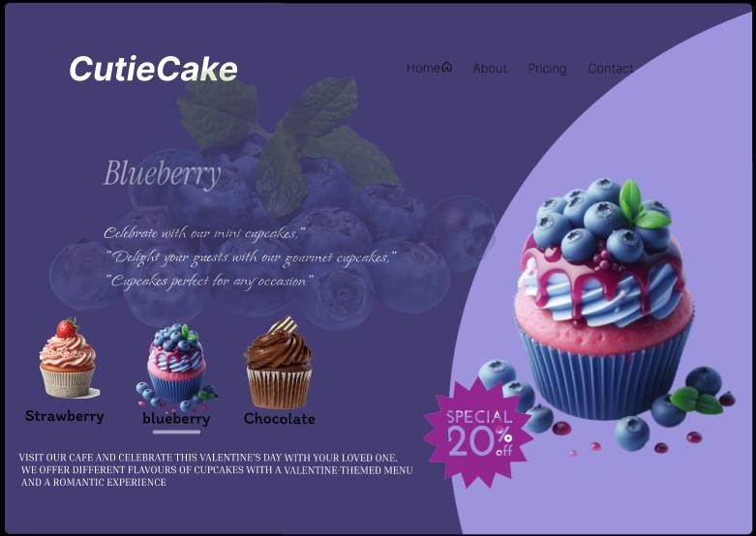

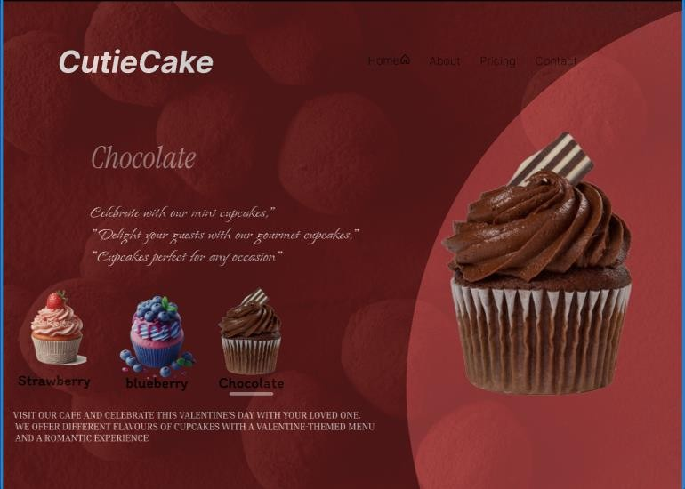
PROTOTYPE LINK:
https://www.figma.com/proto/VXdKyt0d79rBMQRp8GZwpa/Untitled?node-id=49-3&starting-point-node-id=49%3A3
The two websites have distinct designs and approaches. Here's a comparison:

BAD WEBSITE (CakeBake)
- Design Style:
  - Minimalistic and clean layout.
  - Focused on showcasing cupcakes with large, colorful images.
  - Uses vibrant and contrasting background colors (turquoise, pink, maroon) for different cupcake categories.

Content:
  - Displays three cupcake varieties with their names and a “View More” button.
  - Content is direct and concise.

Navigation:
  - A minimalist navigation bar with icons (e.g., cart and user profile).

Purpose:

  - Likely designed for e-commerce or product browsing.

GOOD WEBSITE (CutieCake)
- Design Style:
  - More elaborate, with a themed and artistic layout.
  - Each section highlights a specific flavor (Strawberry, Blueberry, Chocolate) with matching visuals and colors.
  - A soft and playful vibe, with background patterns and imagery complementing the cupcake flavor.

Content:
  - Includes descriptive text about each cupcake flavor, emphasizing celebration and special occasions.
  - Features a “Special 20% Off” promotional offer.

Navigation:
  - A broader navigation menu at the top, including links to Home, About, Pricing, and Contact.

Purpose:
  - Appears to focus on branding and creating an engaging experience, possibly for a bakery or café.

Key Differences:
- Focus: The first website is product-centric, while the second emphasizes storytelling and branding.
- Design Aesthetics: The first is simple and functional; the second is thematic and visually rich.
- Content Depth: The second provides more detail and promotional content, whereas the first focuses on simplicity.
- Target Audience: The first seems tailored for online shopping; the second is for building brand connection and promoting offers.

